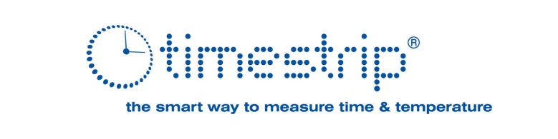
News release
Demand for Temperature and Time Indicators Increases
24th March 2020 - Cambridge, UK –Timestrip is experiencing increased demand for its ‘smart indicator’ technology as the coronavirus outbreak triggers major testing programmes and renewed hygiene measures across the world. Timestrip’s range of chemical-based indicators monitor temperature or time, and provide clear indications when a specified condition is met.
Laboratories carrying out COVID-19 testing must follow guidelines from the World Health Organisation (WHO), which state that swab specimens must be stored and shipped at between 2°C and 8°C.
Timestrip supplies specific temperature indicators for this range, so that any temperature breach can be spotted quickly by attaching an irreversible indicator label to the specimen. When there is likely to be a delay in samples reaching the laboratory, other required measures include freezing the specimens to below -20°C or ideally -70°C, and again, Timestrip products support this requirement.
Preventing infection in health workers and avoiding the spread of COVID-19 amongst patients is critical. In one Timestrip application, filters for face masks carry time-based indicators so that they can be replaced regularly to maintain their efficiency.
Timestrip time indicators are used to provide an indication to healthcare staff when equipment such as hospital curtains are due for replacement. These curtains and other semi-fixtures can carry viruses and bacteria, helping to spread infection as individuals come into contact with them on a regular basis.
“In common with many organisations, we are keen to do all we can to help fight the COVID-19 pandemic”, says Nora Murphy, Commercial Director of Timestrip. “Several of our standard products are designed to address the specific challenges of the response, and we are ready to develop any custom applications that may become necessary.”
Timestrip was recently identified in the ‘Top 10 Emerging Technologies of 2019’ by Scientific American magazine.
<ends>

Notes to Editors
Editorial contact:
Terry Nicklin
Keynote^{PR}
Tel: +44 (0)7923 540695
E-mail: terry@keynotepr.com
Company contact:
Nora Murphy
Commercial Director
Timestrip UK Ltd
E-mail: nora@timestrip.com

About Timestrip
Timestrip® is an agile technology business that designs and manufactures time and temperature indicators. The company works in partnership with global brands, leading OEMs and product designers. Timestrip Enabled™ products drive changes in supply chain standard operating procedures and consumer behaviour, which in turn leads to greater product safety, product authenticity, regulatory compliance and reduced wastage. Products incorporating Timestrip indicators have a built-in value-added proposition.
Timestrip indicators are capable of monitoring time from one hour to two years, and temperatures from -20 degC to 53 degC. In addition to a core product range, a research and development team develops new products for bespoke applications, replacing the need for expensive and unstable electronic components.
The products are low cost, making them suitable for a wide range of monitoring applications in the food, pharmaceutical, healthcare and many other sectors. To date, Timestrip has manufactured and sold over 100 million products to customers worldwide, including 3M, Tesco, Parker Hannifin, Siemens and Febreze. They are a previous winner of a UK NHS Innovations Award.
www.timestrip.com

